Mplus homework M&S – 1

Below are the Mplus homework exercises. Do not forget to make the analytical homework as well!

Exercise 1.
Consider Example 5.1 from Mplus: Carefully read the explanation in the Mplus User’s Guide (http://www.statmodel.com/ugexcerpts.shtml, and go to Chapter 5). TIP: To run this model, make sure the inp-file (i.e., the input file) and the data file are in the same folder.

a. How many sample statistics are there? Indicate how you obtained this number.

b. How many free parameters are there? Describe them (i.e, how many factor loadings etc.)

c. Hence, how many df are there?

d. Which defaults does Mplus use when running this model?

e. Draw a path diagram of the model, and indicate where the free parameters are.

f. What do the model matrices Λ (=Lambda), Ψ (=Psi), Θ (=Theta), ν (=nu) and α (= alpha) look like?

g. Run the model (by pressing the button RUN) and describe the model fit. What can you conclude about this model?

h. Is there a need to consider Modification Indices? Explain your answer.

i. Consider the parameter estimates: Are they all significant? If a parameter is non-significant, what does that mean?

j. Adjust your model in light of the previous question. TIP: Check the options for the Model Command in the Mplus User’s Guide (see pdf version the website of Mplus; chapter 17); this provides information on how to fix a specific parameter to a certain value, (e.g., @1 to fix at the value 1 or @0 to fix at the value 0), and how to refer to covariances and means in the model. How did you adjust your model?

k. Run the adjusted model. How many parameters does it have? How can you compare this model to the previous model? Compare the models and report your findings.

Exercise 2

Consider the SPSS file Grnt_mal.sav. This file contains the scores of 72 boys on 6 measures:
visperc Visual perception scores
cubes Test of spatial visualization
lozenges Test of spatial orientation
paragraph Paragraph comprehension score
sentence Sentence completion score
wordmean Word meaning test score
It is assumed that these 6 variables measure two factors, that is Spatial Ability, which is measured by the first three variables, and Verbal Ability, which is measured by the last three variables.

a. Draw the path diagram that represents this model.

b. Write down the model in regression equations.

c. How many observed statistics are there (which ones)? How many parameters are there (which ones)? So how many df does this model have?

d. Save the file in SPSS as a tab delimited dat-file (see below). Make sure that you do not save the variable names (uncheck the box). Save the data in the folder you use to run your Mplus models from.

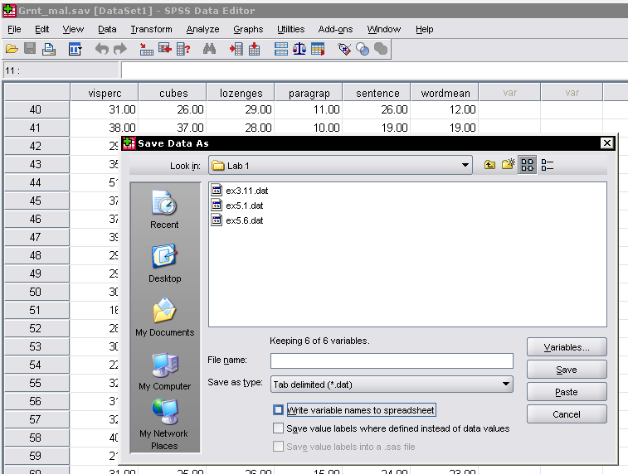

e. Specify the two-factor model in Mplus and run this model. Report on the model fit. Is there a need to modify the model? Explain your answer.

f. Based on the parameter estimates, would you say Spatial Ability and Verbal Ability are strongly related? Explain your answer.

g. Run the model again including:

OUTPUT: TECH1 STDYX TECH4;

to obtain the standardized results. Is this helpful with respect to the previous question? Explain your answer.

h. As explained in the lecture, each latent variable (or factor) needs to be scaled. Scaling can be done by fixing a factor loading to 1, and this is what Mplus does by default. Compare the following ways of specifying the two factor model:

Method 1:
MODEL:
SA BY visperc cubes lozenges;
VA BY paragrap sentence wordmean;

Method 2:
MODEL:
SA BY cubes visperc lozenges;
VA BY paragrap sentence wordmean;

Are these models different or the same? Explain your answer.

i. You can also scale a factor using the factor variance, rather than one of the factor loadings. This implies you have to overrule the default of fixing the first factor loading to 1, which you can do by saying:
MODEL:
SA BY visperc* cubes lozenges;
VA BY paragraph* sentence wordmean;

(the asterix implies this parameter—factor loading here—will be estimated freely. In addition, you need to fix the variances of the factors to a positive number (for instance 1), which you can do by adding this to the MODEl statement:

SA@1;
VA@1;

Run this model, and discuss the results.

j. What can you say about the covariance between the factors when using this model specification?

k. The one-factor model is nested under the two-factor model. You can specify a one-factor model in Mplus, and use a chi-square difference test to compare the one-factor model to the two-factor model. Alternatively, you could constrain a parameter in the previous model such that it becomes equivalent to the one-factor model. Which parameter is this, and to what value should it be constrained?

l. Use both approaches and compare the results (model fit should be the same). Also perform a chi-square difference test to determine whether this constraint can be imposed. Explain your conclusion.

Exercise 3

Consider Example 5.6 from Mplus. This is a higher order factor model, where the four first-order factors are indicators of the second-order factor. Such higher-order factor models are for instance used in intelligence research, where diverse abilities (verbal ability, spatial ability, working memory) are modeled as first order factors, which are in turn indicators of a second order factor which is interpreted as general intelligence.

a. How many sample statistics are there (which ones)?

b. Draw a path diagram of the model used in exercise 5.6, and indicate where the free parameters are.

c. How many free parameters are there (which ones)? So how many df are there?

d. If you run the model and ask for the TECH1 output, this is what you get:

TECHNICAL 1 OUTPUT

PARAMETER SPECIFICATION

NU
Y1 Y2 Y3 Y4 Y5
________ ________ ________ ________ ________
1 1 2 3 4 5

NU
Y6 Y7 Y8 Y9 Y10
________ ________ ________ ________ ________
1 6 7 8 9 10

NU
Y11 Y12
________ ________
1 11 12

LAMBDA
F1 F2 F3 F4 F5
________ ________ ________ ________ ________
Y1 0 0 0 0 0
Y2 13 0 0 0 0
Y3 14 0 0 0 0
Y4 0 0 0 0 0
Y5 0 15 0 0 0
Y6 0 16 0 0 0
Y7 0 0 0 0 0
Y8 0 0 17 0 0
Y9 0 0 18 0 0
Y10 0 0 0 0 0
Y11 0 0 0 19 0
Y12 0 0 0 20 0

THETA
Y1 Y2 Y3 Y4 Y5
________ ________ ________ ________ ________
Y1 21
Y2 0 22
Y3 0 0 23
Y4 0 0 0 24
Y5 0 0 0 0 25
Y6 0 0 0 0 0
Y7 0 0 0 0 0
Y8 0 0 0 0 0
Y9 0 0 0 0 0
Y10 0 0 0 0 0
Y11 0 0 0 0 0
Y12 0 0 0 0 0

THETA
Y6 Y7 Y8 Y9 Y10
________ ________ ________ ________ ________
Y6 26
Y7 0 27
Y8 0 0 28
Y9 0 0 0 29
Y10 0 0 0 0 30
Y11 0 0 0 0 0
Y12 0 0 0 0 0

THETA
Y11 Y12
________ ________
Y11 31
Y12 0 32

ALPHA
F1 F2 F3 F4 F5
________ ________ ________ ________ ________
1 0 0 0 0 0

BETA
F1 F2 F3 F4 F5
________ ________ ________ ________ ________
F1 0 0 0 0 0
F2 0 0 0 0 33
F3 0 0 0 0 34
F4 0 0 0 0 35
F5 0 0 0 0 0

PSI
F1 F2 F3 F4 F5
________ ________ ________ ________ ________
F1 36
F2 0 37
F3 0 0 38
F4 0 0 0 39
F5 0 0 0 0 40

Can you relate the parameters in these matrices to the parameters in the path diagram you drew? Indicate what is new.

e. If we are interested in the covariance matrix or correlation matrix of the first-order factors, how can we get these?

